Purple Lady Workshop 2015
3-4 October

OK folks here we go:- If we want Linda to come back for this workshop we have to have a minimum of 15 people (maximum 25), £30 deposit paid by the end of February. The price will be £60 for the workshop plus the cost of the kit, the price of which you can see below. As usual at our workshops lunch will be provided both days and a group booking will be arranged for a meal Saturday night for anyone wanting to attend. This is normally at a Chinese restaurant in Swindon and costs around £20 per head plus drinks. If you have a second person accompanying you the cost to cover lunches will be £10.
On offer this time is a banner the same size as last time but with the aquarium design.
Kit cost £50.

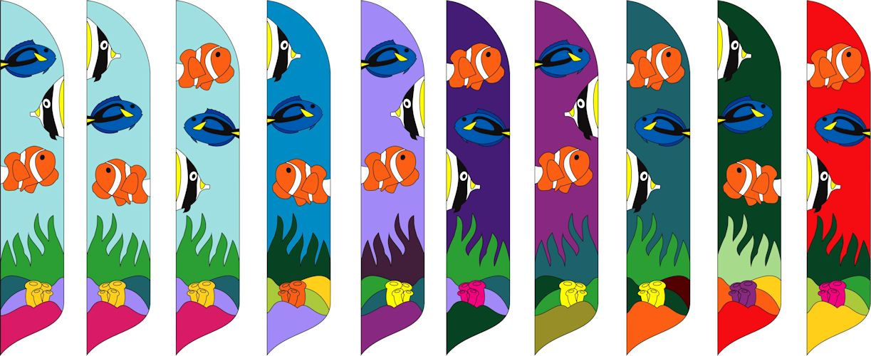

or a SkyFeather with your name or company of up to 10 letters plus a graphic yet to be decided.
Kit cost again £50.

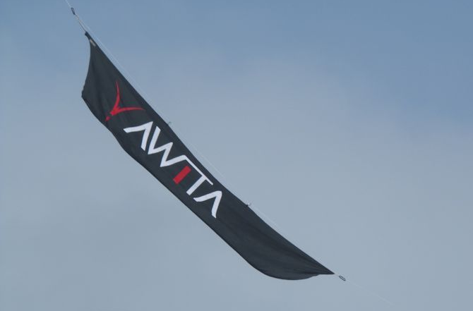

Any special design requirements must be discussed directly with Linda but can only be supplied as part of the workshop as she does not supply kits directly. If you are doing the aquarium design you can purchase all 3 designs so that you can complete the set at home.
Please note the kit price does not include a pole or ground stake and the cost of the template print is included in the workshop price for one standard design only, so if you are making all 3 of the aquarium you will need to arrange with some one else to exchange prints or we could supply at an extra cost. Those with non-standard designs would need to provide their own print or again we could probably arrange at an extra cost.
Please let us know as soon as possible if you intend to do this workshop. Payment can be made by direct transfer to WHKF at RBS, sort code16-33-11, account 12573018 or by cheque to WHKF sent to The Treasurer. Please contact us for this address as the PO box number has been discontinued.

