
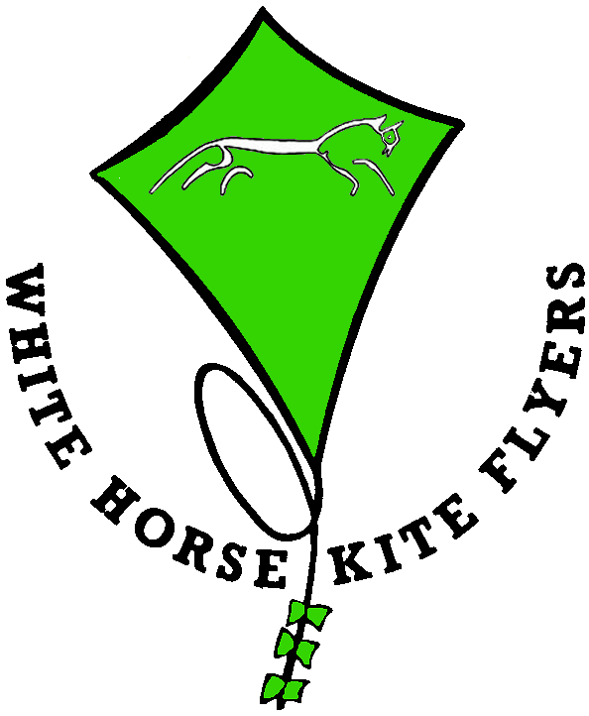

We can supply fully manned workshops for your event. WHKF carry third party liability insurance for their members running these workshops. We also have available Risk Assessment documents if required.
Workshops can take two formats the first of which is suitable for general events such as country shows etc. At these the individual will be guided through making their own kite by one of our members and will then take away their kite. The next individual will be assisted in the same way. We require about a 4ft frontage for each workstation so allowing for access a 20ft tent would allow for 4 people at a time to make kites and would therefore require 4 of our tutors. For this style we do not require CRB clearance as contact duration and frequency are very low.
The other format is suitable for group events such as scouts, guides, summer schools or school classes. At these each participant will be issued with the parts as required and an instructor will lead the class through the process of making the kite. The whole group would then be taken to a suitable venue where they could fly the kites they have made. At this sort of event assistants will be required to help participants who have difficulties at any stage. The organisers will be required to supply the scissors for cutting out the sails and will have to have some one who is CRB cleared present at all times.
Charges will include insurance and be dependent upon: - mileage, expenses, equipment we have to supply (e.g. tentage, tables, chairs etc.) and the number of people for your size of event. Kite Kits will be charged for as detailed in the Kite Kits page and are charge to the individual in the first format or as total number used to the organiser in the second format.

