
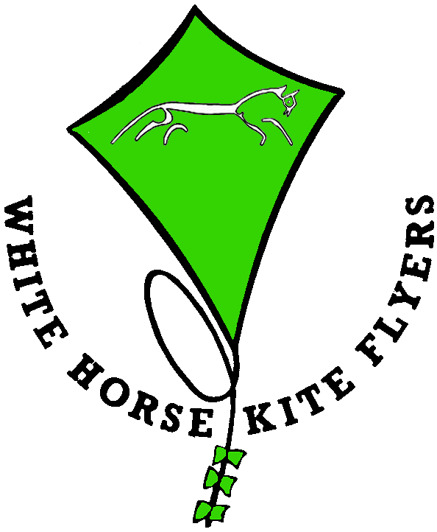

White Horse Kite Flyers have a number of people who can give illustrated talks to school classes, scouts and similar groups.
These can be linked to projects on flight, colour, movement, history, geography and many other subjects.
The display is primarily via Power Point Presentation on overhead projector that can be supplied or other formats for your own system including CD or USB pen.
Kites, lines, safety equipment etc will also be used and making a simple paper kite can be included at a small extra cost.
Should you require a talk on any specific branch of the hobby we have a large number of contacts who can talk on many subjects from the history of kites, their development and uses to the aerodynamics involved and many in between. Just ask and we will see what we can do.

Charges will vary dependant upon the lecturer and the distance they have to travel.

