
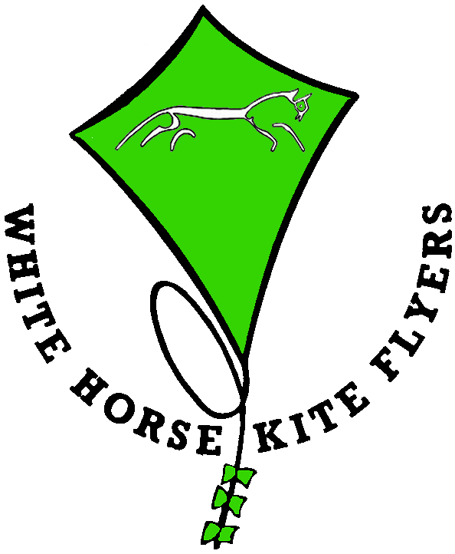

White Horse kite Flyers has several groups who regularly parachute teddy bears. We launch a large kite from which we suspend a pulley system that can pull a payload up towards the kite. On occasions when there is no wind or no space this system can be attached to any high fixed point such as a church tower, fire engine ladder or anything else suitable. Most of our teams use an electric winch to drive the pulley system but if all else fails this can be done manually.
You then supply the children who have all been told in advance to bring a teddy bear or similar soft toy. You would then take the fee at whatever level you see fit, usually between £0.50 and £2.00 per drop. We fit the bear with a suitably sized parachute and then it is winched up and released from height. If all goes according to plan the bear will then drift slowly back to the ground when its owner will chase after and retrieve it. We then remove the parachute, return the bear to its rightful owner and a certificate can be awarded.
It should be noted that although bears have ended up in trees, on roofs, in lakes, rivers and the sea we have never lost one, yet.
Our charges for this are to cover insurance, travel, expenses and a contribution to wear and tear of the equipment. We can also supply the certificate at a small extra cost.
If we are to use a kite and the day proves windless we still have to charge our travel, expenses and insurance.
As with all WHKF activities we have a Risk Assessment available and are covered by third party liability insurance.

For more details on how this is done go to http://www.tedberets.co.uk

