
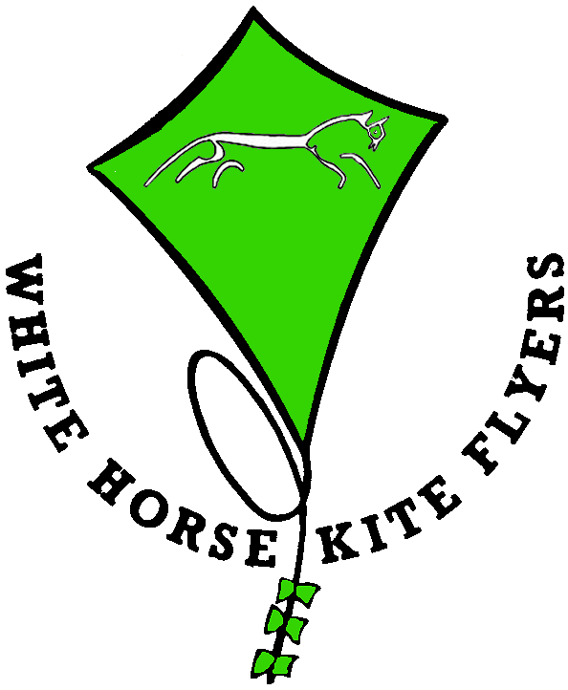

????? What do you get in a kite kit ????

Every thing you need to make the WHKF sled kite. This includes: -
1) 1 printed skin. This is supplied uncut as a square sheet with instructions printed round the edge.
2) 2 garden cane spines
3) 100mm reinforced tape for bridle holes
4) 400mm p.v.c. tape for fixing spines and tail
5) 1 tail
6) 1 bridle
7) 1 flying line on handle

????? What does this cost ????

For the basic kit £1.50 each

CD. with PowerPoint instructions and pictures £2.20

500 printed skins £100

Post and Packing charges will be added to these prices
Note: We are not registered for V.A.T.

Please allow us 2 weeks to prepare and deliver orders

Minimum quantity of kits 25

Under special circumstance such as lock down restrictions during a pandemic, these quantities and prices may be reduced for groups providing on-line learning or similar facilities.

