
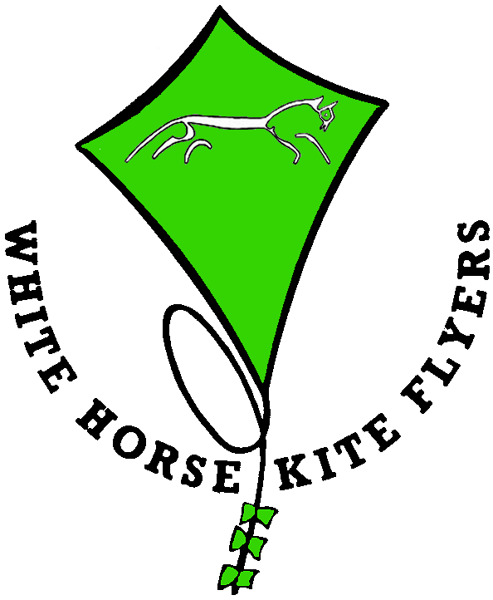

Indoor
White Horse Kite Flyers has a large range of education, informative poster and pictures to enhance an indoor display of their many and varied kites.
Cost would be determined by the location and the number of visits required to display and remove our exhibits. We would expect you to have insurance cover for our items whilst they are on you premises.

Outdoor
White Horse Kite Flyers has a huge number of club and personally owned kites that they fly at events not only in the UK but also across Europe and even America. They also have flyers skilled in most Kite flying disciplines including the huge single liners with big wind-socks, kite trains, arches, miniatures, Indian and Rokkaku fighting, two lines and four lines with or without music, Kite Aerial Photography, teddy bear parachuting and a few traction specialists.
If this is what you want you must realise that we need a very large area roped off from the public for safety reasons. This area must be at least 100x100yds. It also takes a lot of time to get a display in the air and more to get them down so a 15-minute slot in a small arena is not suitable. You should also note that kites do not mix with horses or birds of prey if they are of a nervous disposition. Also trees tend to eat kites and we will not fly anywhere near power lines, transmission towers, roads, railways or airports.
Due to H&S requirements it is very difficult to provide a hands-on flying display, as kites can be very dangerous with high speeds and enormous lifting capability. For similar reasons we no longer do man-lifting.
As putting on a good display requires many kites it also requires many people to assemble and fly them and this must be reflected in our charges that are based on travel, expenses and insurance.
Please contact us with details of what you require, including location and duration and supply us with details of the space available.
We have in place Risk Assessments and insurance for all our activities and we comply with CAA regulations.

