
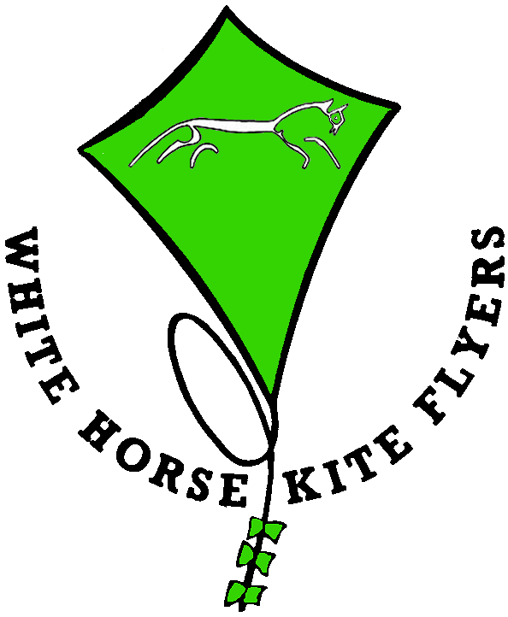

We can provide Kite making workshops supplying all the materials to make various designs of kite suitable for beginners with an experienced tutor. For these you would require a suitable venue and participants would each require their own sewing machine and have basic sewing skills. As an example A 2 day course perhaps running from 10AM until 5PM each day with tea, coffee and lunch breaks as required. We would start with a presentation on kites, the modern day materials we use for making them and the problems encountered with sewing them. We would then provide all the materials, for each participant to make and fly a hexagon kite of about 4ft apex to apex as shown below. If there is a suitable location the session would be finished with all participants flying their new kites. An approximate cost for this would be £35 per person plus travel, expenses and insurance.
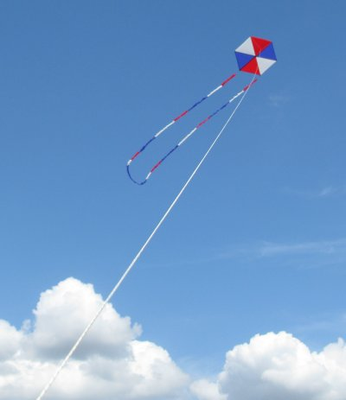

For more advanced designs we have a large contact list of top national and international kite makers who can come to run workshops.

