Continuing to build on my preparations. So far:
- Whiteboard & pens / wiper ... OR ... easel & paper & textas - Often, the simplest way to explain myself is to draw it. I used this method all the time with school workshops - kids enjoyed watching pictures rather than blah blah blah words. These will be supplied by WHKF
- Probably standard tools to pack, but a stitch ripper / unpicker.
- Black thread is what we use. It provides delineation between coloured pieces, much like lead beading in leadlight in windows.
- Anyone who uses a binding tape attachment - needs to take 20mm tape - may bring theirs for the final stage. If not, then people may opt to double fold hem.
- Double-sided sticky if they're not confident about fold-and-sew all in one.
- Their hot iron / cutter or dotter with a cord long enough to ?throw over their shoulder. (We suspend our electrical cord from an overhead wire, that way the weight of the cord doesn't upset the holding of the iron.)
And now.
Paper patterns.
Each person will require their own full sized paper pattern. Not to be used for cutting from as the fabric will already be in the individual pieces.
But to be used a the background guide for which piece goes where.
OPTION #1
I can email the .pdf nearer the time and you can ask / pay someone with a wide format printer to print off 9 x Lattice and 16 x China Lady patterns.
Each one would be 2.7m long by minimum 60cm wide paper. And could possibly COST you (unless you have a generous sponsor with that much paper, ink and time to spare) - for which the participants would have to pay.
Or.
OPTION #2
We've sorted out how to prepare the pattern as a .pdf suitable for each participant to print off on their OWN machines in advance of the workshop, using a Tile format.
They can print off the 38 or so pages in their OWN TIME, and can stick them together to make the full pattern then bring their own with them to the workshop.
The pattern doesn't need to be accurate to the last millimetre. It's only a GUIDE when assembling the fabric pieces.
These prints have been done by Roy using the reverse side of his used transfer paper. If you do have your own facilities please let me know.
Sound good?
Linda

- The Orange iron is a Weller, the code on the plate includes "40D" so I'm presuming that's 40Watt.
I THINK Kevin buys the chisel tip iron refills, then files them to a rounded-point?
The ruler in the photos is showing mms.
You'll see that I like a shortish distance between handle and tip - much shorter than how those welding irons are on that website. To me, when I'm using it, it feels like a pen, only just a bit longer.
The additional iron with the bent tip is Kevin's new "toy".
Still playing with it to see if he's comfortable with it.
I'm a Calligrapher, so working with an ink nib feels much the same as using a hot-cut iron.
Kevin's NOT a lover of writing, so pens are less easy for him.
While the ruler shows that the very tip measures 1mm, it's not a FINE point, so that when it sinks into the fabric, the hole it makes will be slightly larger than 1mm from the front, but still, hardly noticeable from the back.
The secret is in applying the left hand finger OVER the weld while it's still hot. Pushing the fabrics together. Shown here compared to a packet of sewing needles.

I'm thinking that folks who try hot-welding are working on ripstop, and use a tip which matches that of a pencil.
Too small for what I do. The welds aren't big enough / firm enough.
(On ripstop nylon, those welds look ugly, which explains why folks use a smaller tip.)
On banner nylon, the welds are visible UNTIL they have that zig zag over, and then they're just not easy to spot.
Size of the overlap of fabric should be approx 3mm. since that's how wide the pattern lines are when cutting out.
Hot-welding doesn't need glass underneath, nor does it need the pattern itself.
Well, at least, that's what I shall be practising after the Christmas rush is over.
I use a soldering iron ?40W I believe. (This technical info. I'll need confirmed from Kevin.)
Am I right in thinking that your electrical power supply is the same voltage as ours?
If so, I'm wondering if it's worth bringing MY irons with me - if only to show folks what to use for future reference.
They won't need to CUT anything in the workshop.
I can bring scraps of the banner nylon, and I can show HOW I work it.
If anyone finishes sewing their project early, then can have a practise using my equipment.
For now, I simply wanted to give the eager ones something to chew on during the winter months.
I'll take more photos / step by step / show the steps (in brief) if it helps convince more people to commit.
Don't want to give too much too soon - or they'll wonder why they're bothering to turn up!?!?!
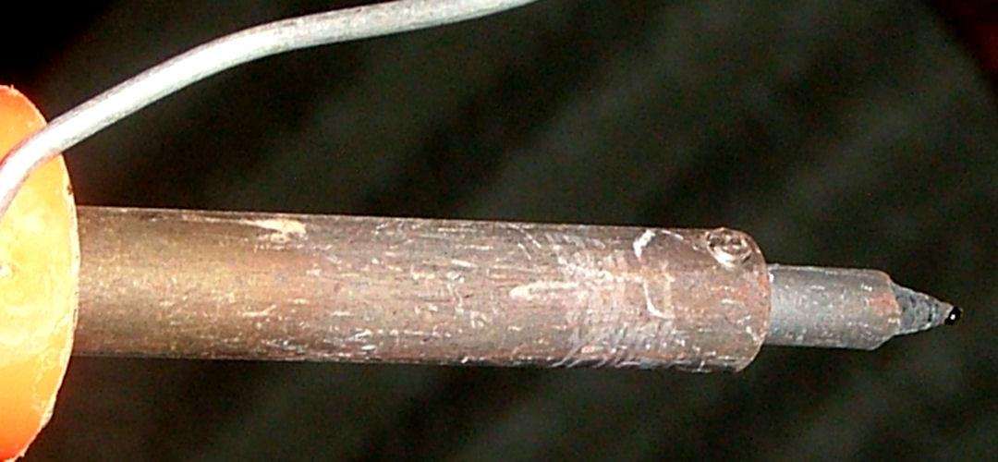
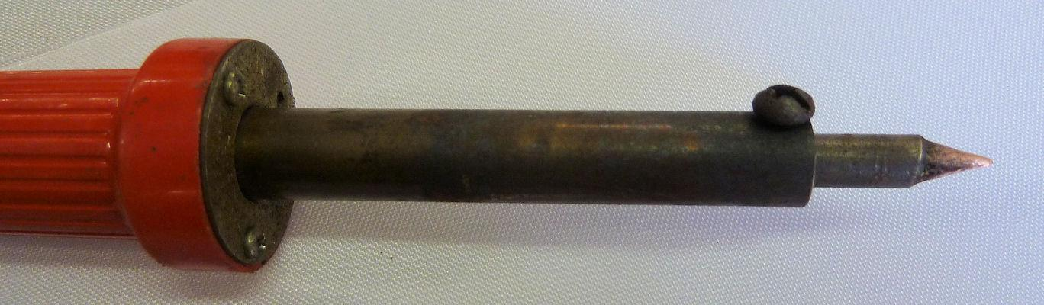
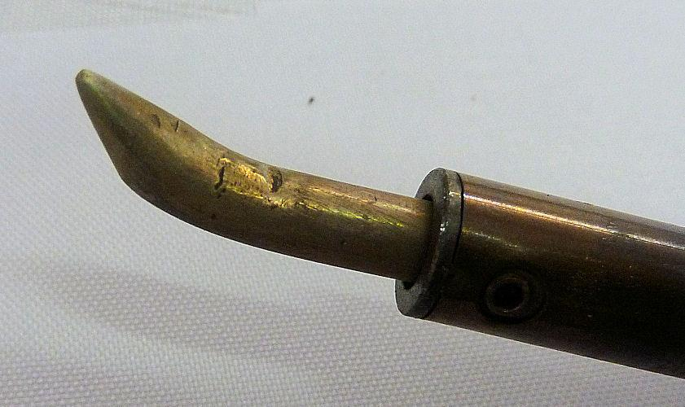
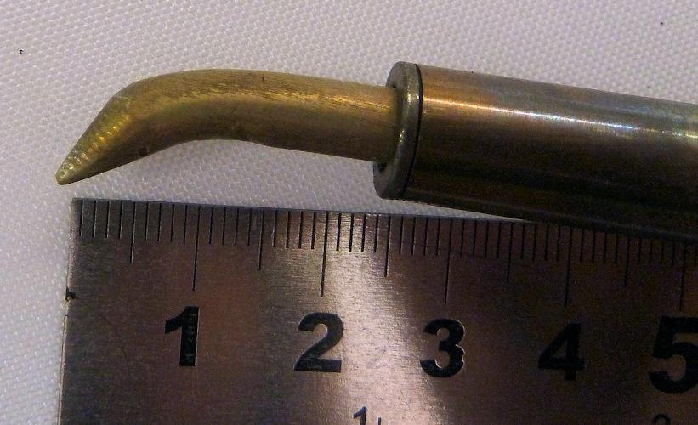
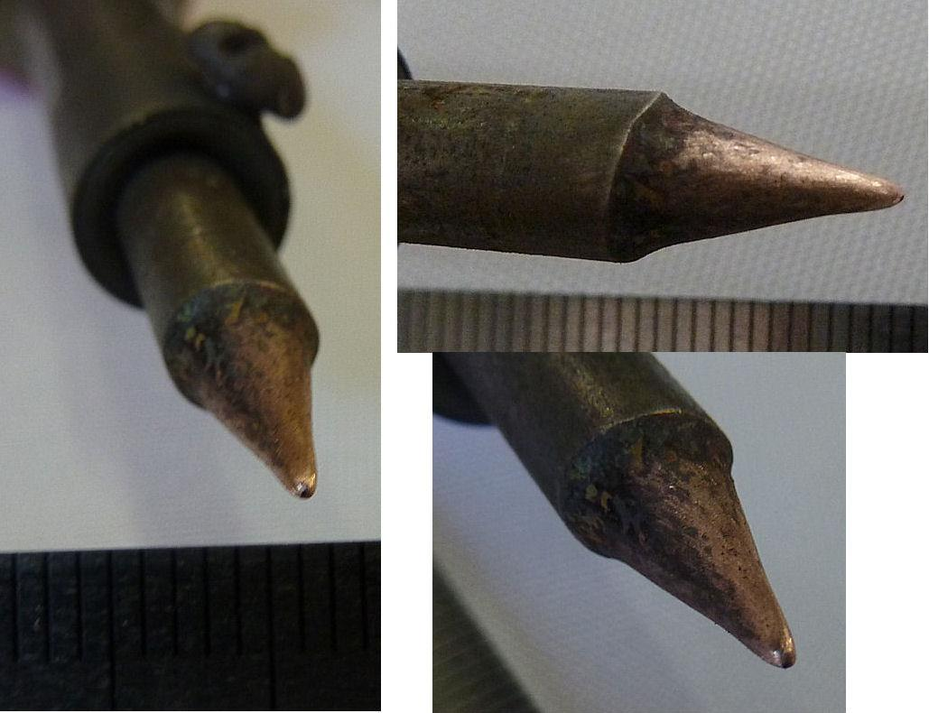
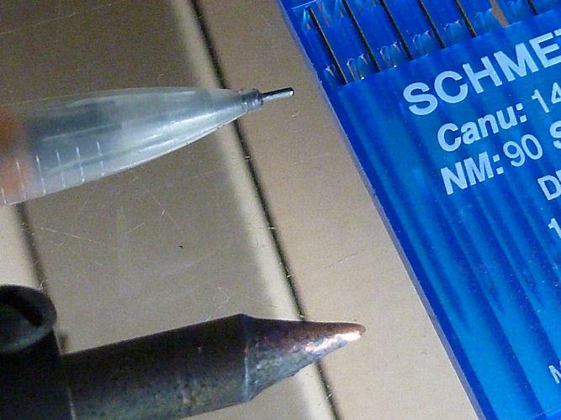

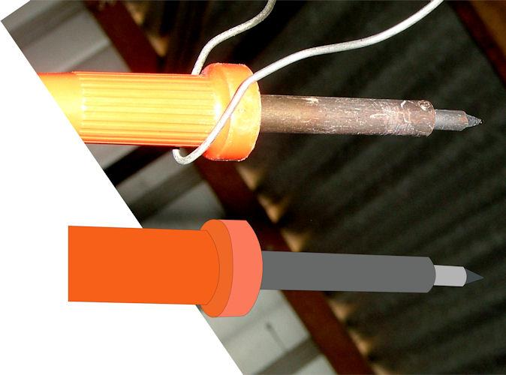
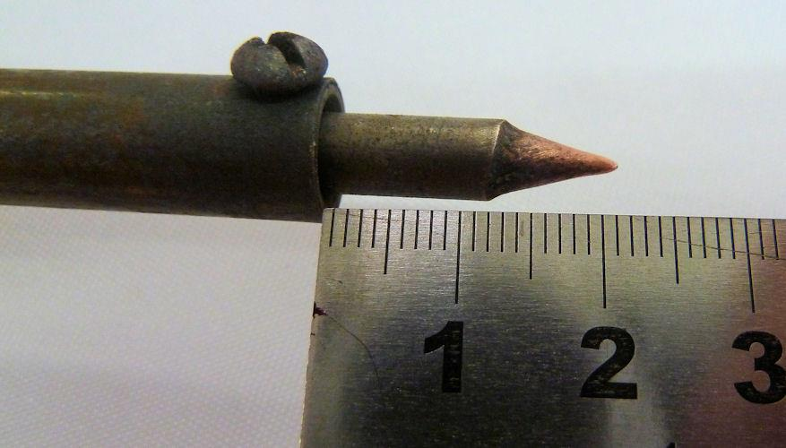

Update photos, now that you're all starting to practise a bit! Dots with ruler alongside, stitching covers the 3mm overlap so the dots sit in the middle of that space. One dot per 3cms, roughly. Using the spare hand / finger to press the hot weld together.

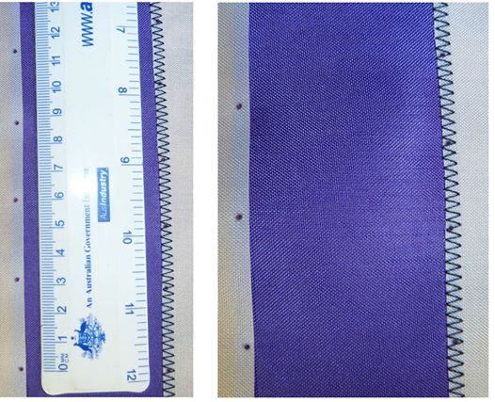

Another update for all you watchers. Getting ready for October.
Practise with your sewing machine doing zig zag stitching, where the stitch completely covers the overlap. Practise straight lines AND circles! I know you can do it!

