6m HAMMERHEAD SHARK LINE JUNK
INSTRUCTIONS
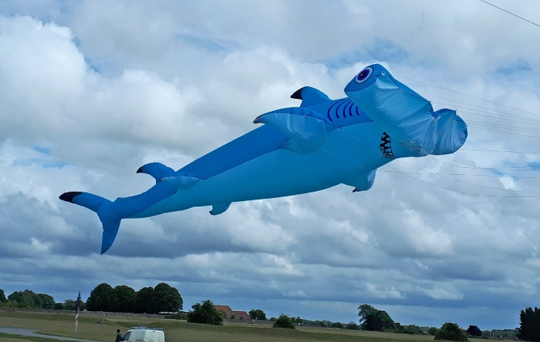
The Hammerhead Shark is basically a large windsock, although it does generate some lift it is designed to be flown from the line of a lifter kite. This is my first attempt at writing a set of kite-building instructions, so apologies if things are not clear enough. Having built plenty of kites following written instructions, I know how easy it is to misunderstand them!
All pieces on the plan are inclusive of a 5mm hem/seam allowance. Nearly all pieces are in pairs which are a mirror image of each other, i.e. one for the right hand side and one for the left so pay attention to which side of the fabric is outermost. In the instructions, ‘good’ side refers to the outer side of the fabric, and ‘wrong’ side refers to the inside.
MATERIALS
8m Ripstop Nylon top colour
4m Ripstop Nylon bottom colour
Scraps of Ripstop of other colours for eyes, teeth & gills
0.5m Dacron tape for reinforcing stress points
50m bridling line
1. First cut out all the pieces as shown on the plan. (The plan is originally drawn on 841mm wide tracing paper.) You can either hot-cut or use scissors, whichever you prefer, although if possible hot-cut the applique pieces for the eyes etc. as it helps prevent fraying. Remember to make one right-hand and one left-hand of all the paired pieces. You will also need to make 15 4cm tabs. To do this, cut a strip of rip-stop 3cm wide, and fold it 3 times lengthways and sew down the edge, then cut into 4cm lengths. You will need 11 of the top colour and 4 of the bottom colour.

2. Cut out and sew on the Dacron reinforcing patches in the positions indicated on the plan. Sew them on to the “wrong” side of each piece, i.e. they should end up on the inside of the finished shark.
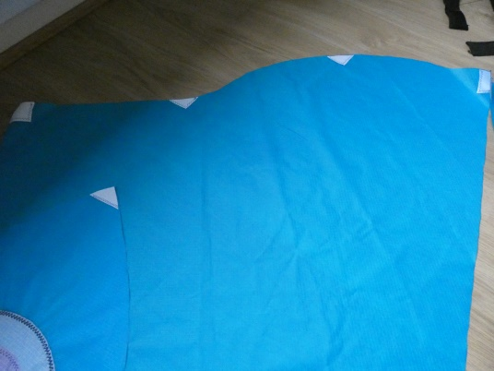
3.Applique the eyes, mouth and gills onto the appropriate pieces. You can either use the plan, or give your shark a unique look by creating your own features. 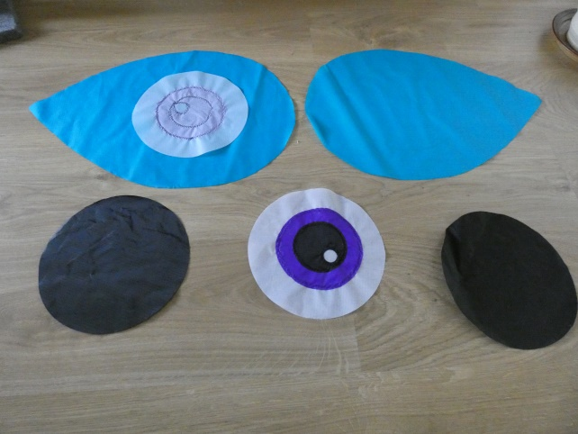 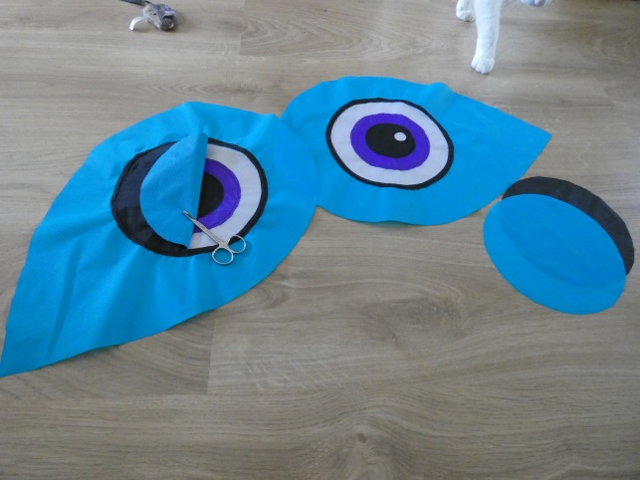
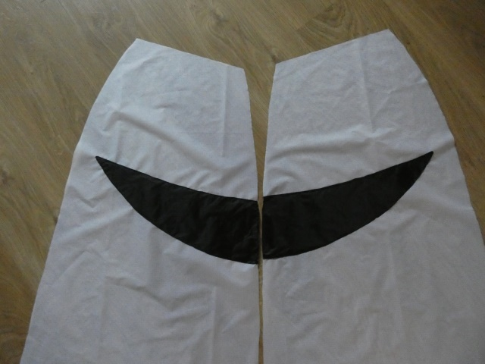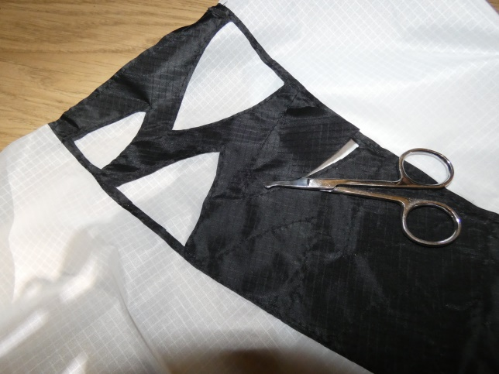
4. Hot cut the circular holes and crosses where shown using a hot knife or soldering iron filed flat. The holes are to allow air from the main body to fill the fins.
5.Hem the rear edge of the nose section and the front edges of the two front body (A)sections. Use a 5mm hem. Reinforce the front edge of the nose with dacron.

6. Sew the rear front (B) sections to the front sections (A), left & right, then sew the two front halves together down as far as the bottom of the mouth, leaving the rest of the seam free.
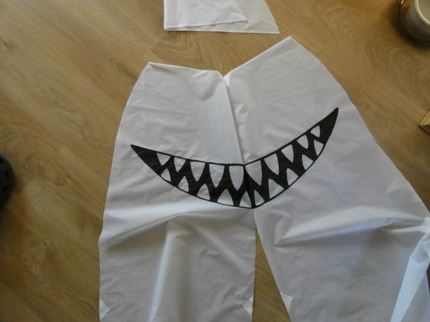
7. Place the front body section on top of the nose section, good sides uppermost. Line up points 1 & 2 of the nose section with the corresponding points on the front body, and sew together down this edge, 5mm in, between the two points, inserting a tab on each side at point 2.
8. Now sew the nose section to the front along the dotted lineto point 3, and sew in a tab at point 3. This forms the air intake.
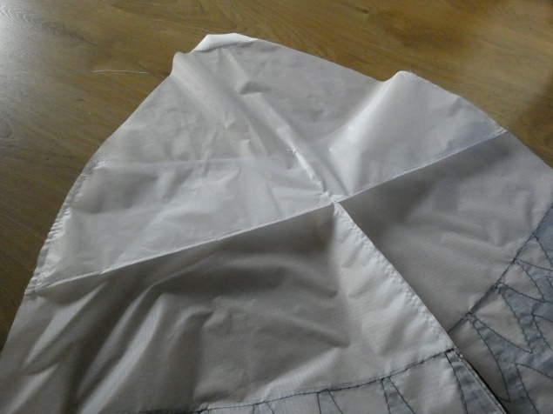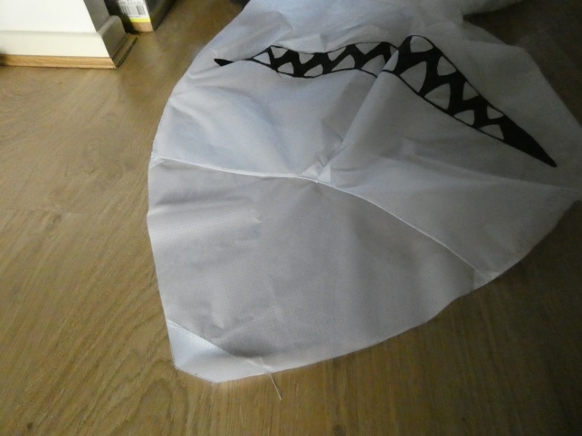
9. Hem the bottom edge of all sets of fins, except the tail. Then sew the two halves of each fin together with a 5mm seam. Place them good sides together, and sew around the curved sides and turn right side out. Remember to insert a tab in each of the front pectoral fins. Fold the 4cm strip in half, and sew it in the seam to leave a small loop sticking out on the good side.
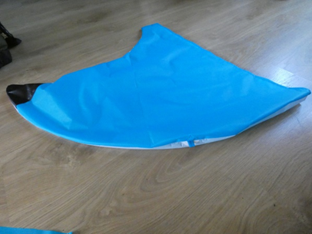
10. Sew the two top head sections to the two main body sections, joining the straight line between points 4 & 5 on the head to the curve between points 4 & 5 on the main body. Start at the front and work backwards, good sides together. Use a 5mm seam, and make sure that the ends match up.
11. Sew the two tail halves onto the two main body sections, left & right, good sides together, between points 10 & 11, using a 5mm seam. *See note below.
12. Now sew the two main body sections together, right along the spine starting at the front, going all the way round the tail to finish at point 11. If you are confident in sewing in zips, you can put one in just before the tail to aid deflation. Sew with good sides together, using a 5mm seam and try to keep everything lined up.
13. Now sew the left and right bottom head sections to the front, good sides together, along the curve between points 4 & 5.
14.Sew the top of the head to the bottom along the leading edge, with a 5mm hem. Add tabs at points 7, 8, 9 and 4 (the centre point). Keep everything lined up. You may find it easiest to begin at the centre (point 4) and work out to one edge, then begin at the centre again and sew out to the other edge. Sew back along this seam with a zig-zag stitch to reinforce it as it takes a lot of stress. The centre front should look like this:
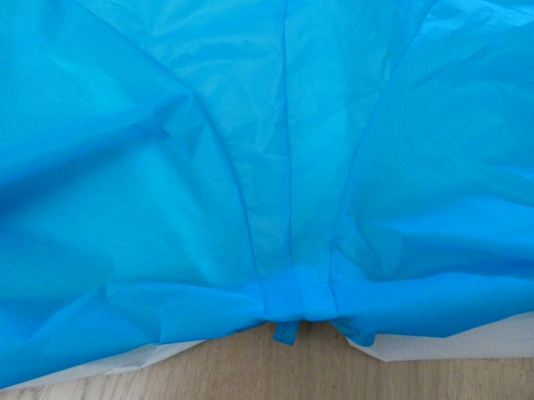
15. Sew the end head sections (with the eyes on) to the top and bottom of the head.Start at the front, good sides together, lining up point X with the seam at point 7, and sew the curved edge to the straight side of the top of the head, around to point 6. Then begin at the front again and sew the lower curved edge to the bottom of the head. Use a 5mm seam, and be careful to line everything up.
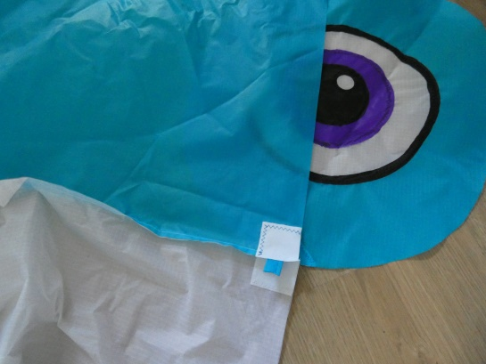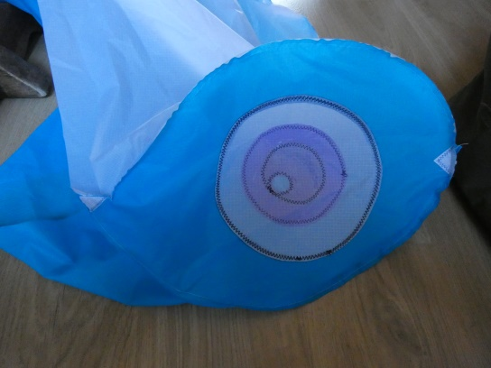
16. Sew the trailing edges of the head together each side between points 5 & 6.
17.Sew on the front and rear dorsal fins. Fold over the hemmed edge and sew along the line, following the dotted lines drawn on the body. Start at the front each side and sew round to the back.
18. Sew the front to the back, starting at point 4 on the underside of the head and sew all along to the tail, good sides together. Take care to line up the markers all along, and insert a tab each side at point 12. This seam is particularly tricky around the curve at the position of the rear fins. Try and keep to a consistent 5mm seam all along. It should all line up at the base of the tail. The main body should all now be sewn up apart from the open seam along the front from the mouth to the base of the tail.
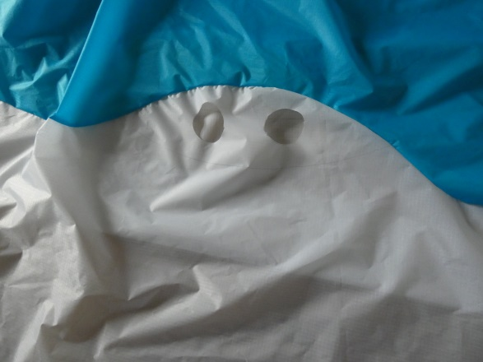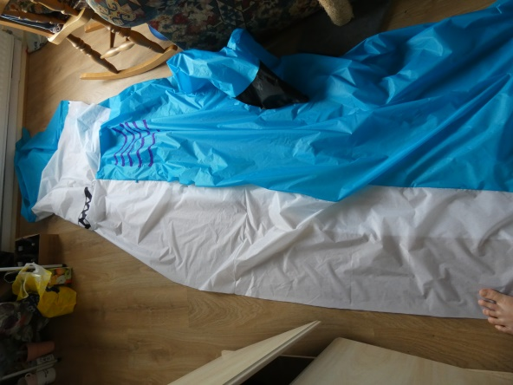
19. Before you can close up the front seam, the pectoral fins front and rear need to be sewn on in the same way as the dorsal fins.
20. With the whole shark still inside out, close up the final front seam, adding the last tab at point 13. You can now pull the whole thing the right way out through the air intake or zip if you have added one. This is a good time to try a test inflation with a fan to check for any mistakes before bridling. Your cat will be unimpressed by this.
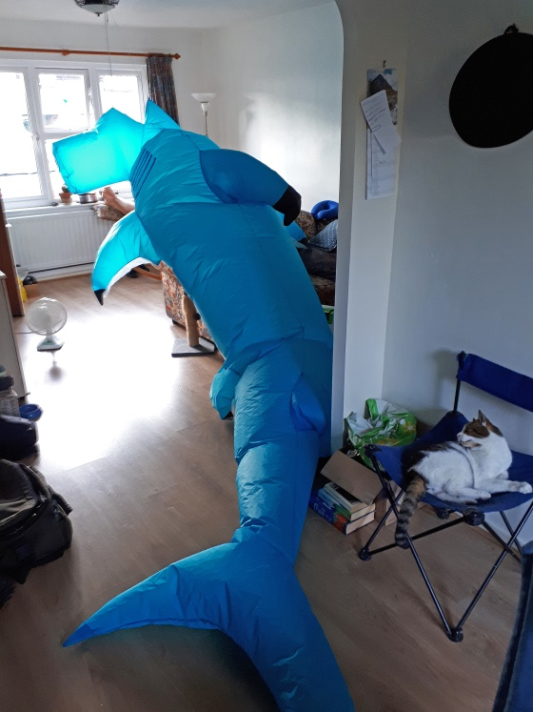

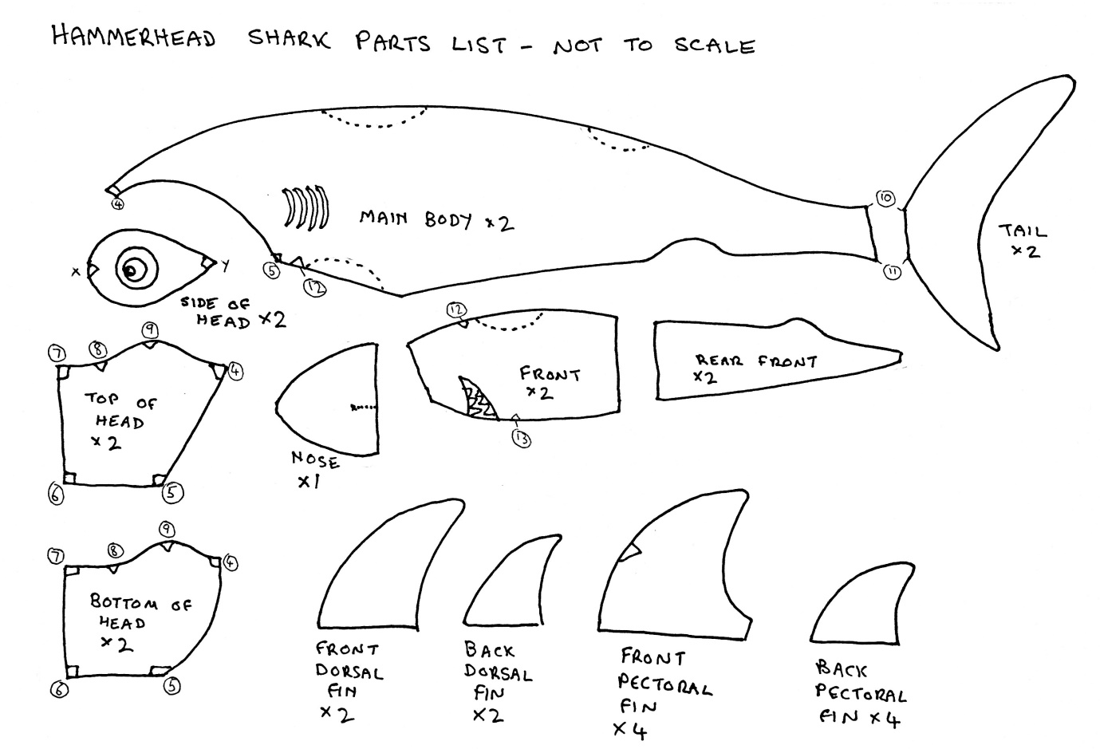

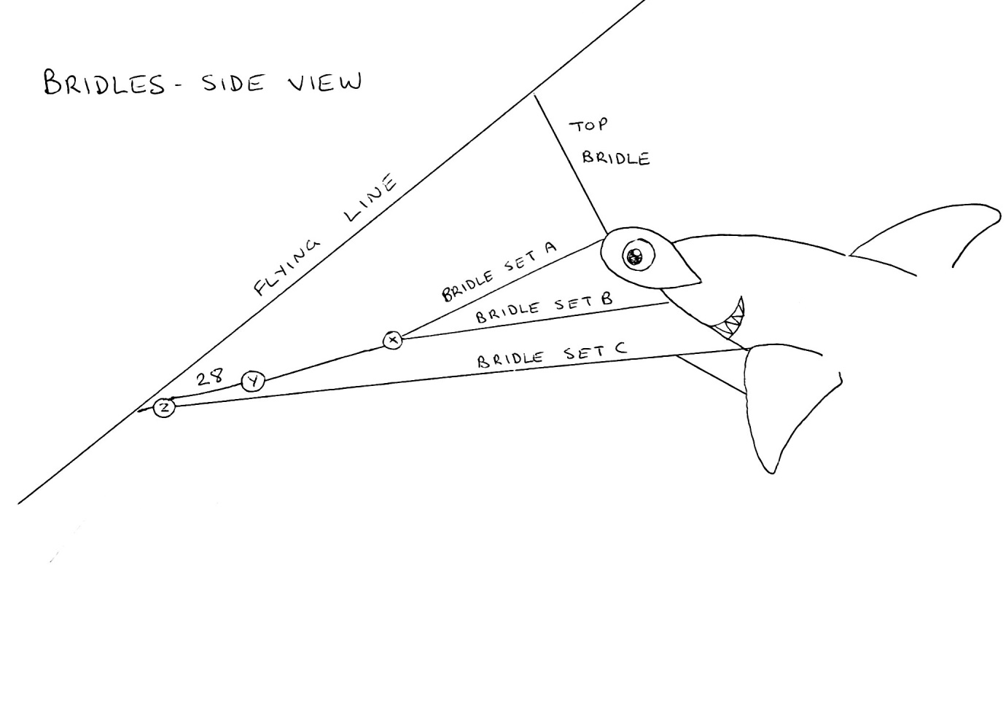
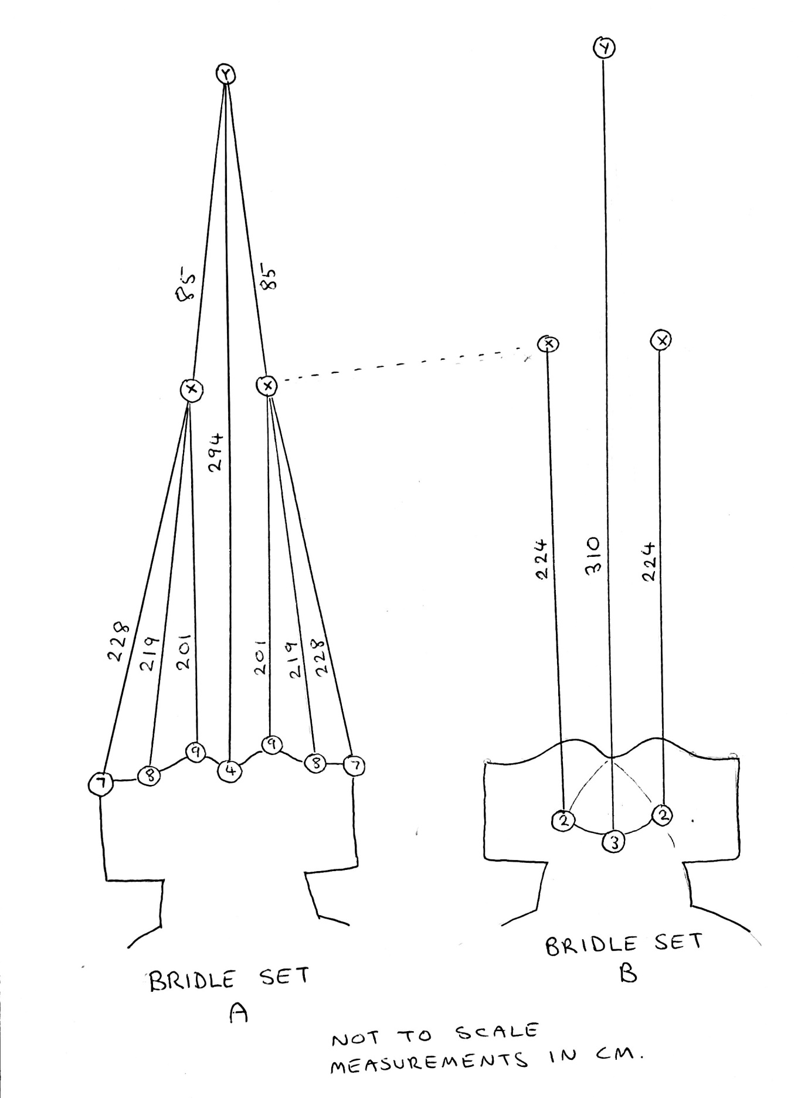
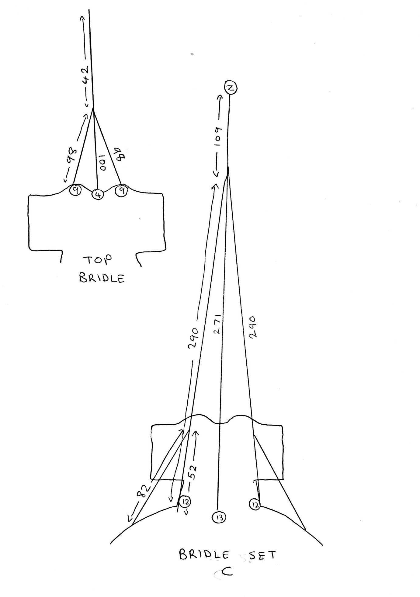
Note there are two attachment points on the flying line. I normally attach the top bridle first and hold the main bridle set whilst the shark inflates, this will show you the best point to attach the main bridle set.
Points to note about the bridle:
The measurements given are the final length, so when cutting lines remember to allow yourself a bit extra to tie the knots!
First tie the top bridle as shown in the diagram. Tie each line to the tabs at points shown using blood knots.
The three lines each side from points 7, 8 & 9 on bridle set A join up with the bridle lines from point 2 in set B at point X. Tie a loop in the end of the line from point 2 and tie the other lines to this with a blood knot. Then tie the two 85cm lines extending forward from point X.
Next add the two long lines from points 4 and 3. These meet at point Y where they also join the two 85cm lines from set A.
When fitting the lines from point 12 in bridle set C, first tie a loop at 52cm in each side, to tie the 82cm line from the front pectoral fins to. Then fit the last line from point 13 in the same way, tie a at the end and tie on the two outer lines, then add the 109cm line at the front, tie a loop in the end at point Z.
Now join points X and Z with a short (28cm) length of line, and finally add a towing point in this short line. This will give you a certain amount of adjustment up or down for different winds. You may find on the first flight some lines need slight adjustment.

*Note When cutting out the tail pieces, to make a flap pocket for emptying out sand after a beach fly, cut one piece whole and the other with the corner cut off plus the small section as shown in the plans. Hem the two edges as shown. Tack the small piece on top of the large, good side out, only sewing along the outside edge and lining up the hemmed edge with the dotted line. When the two tail halves are sewn together, you will end up with a flap which can be opened up to let out the inevitable ton of sand which will be inside.
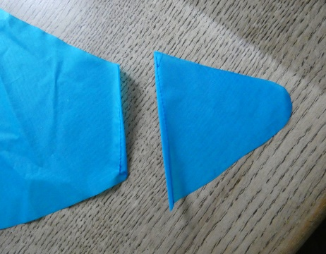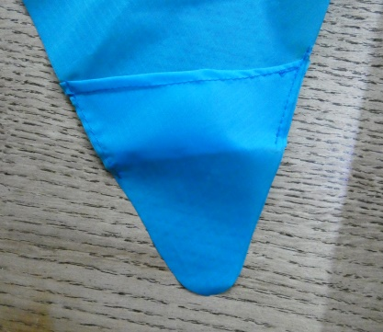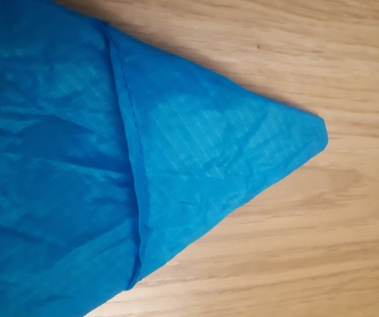
Good luck and happy flying!
David Cross 2020

